**Experiment: 07**

**Date: 27.04.2022**

**Title: Assignment Problem Solution with Excel Solver.**

**Question:**

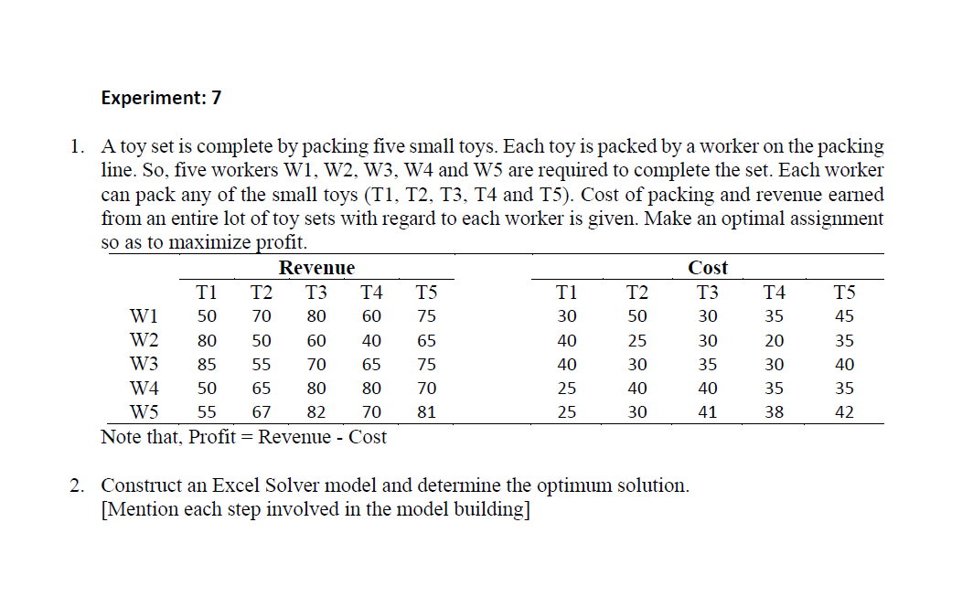

**Answer:**

1. **Formulate the associated Assignment Problem:**

By definition, **Profit = Revenue – Cost.** Hence the profit matrix corresponding to the problem is given by:

|  |  |  |  |  |  |
| --- | --- | --- | --- | --- | --- |
| **To**  **From** | **Profit** | | | | |
| **T1** | **T2** | **T3** | **T4** | **T5** |
| **W1** | **20** | **20** | **50** | **25** | **30** |
| **W2** | **40** | **25** | **30** | **20** | **30** |
| **W3** | **45** | **25** | **35** | **35** | **35** |
| **W4** | **25** | **25** | **40** | **45** | **35** |
| **W5** | **30** | **37** | **41** | **32** | **39** |

**Mathematical Model of an Assignment Problem:**

**Let $x_{ij}=\left\{\begin{aligned} 0 , if worker i is not assigned to pack toy j \\ \\ 1, if worker i is assigned to pack toy j\end{aligned}\right.$**

$C_{ij}=the profit obtained if worker i pack toy j$

**Then the mathematical model for an Assignment Problem is given by:**

**Find $x_{ij}$ so as to,**

$$Maximize Z =\sum_{i=1}^{n}{\sum_{j=1}^{n}{C_{ij}x_{ij}}}$$

**Subject To,**

$$\sum_{j=1}^{n}{x_{ij}}=1 , i=1,2,3,…………….,n (Supply Constraint)$$

$$\sum_{i=1}^{n}{x_{ij}}=1 , j=1,2,3,…………….,n (Demand Constraint)$$

$x_{ij }∊\left\{ 0 , 1\right\} , ∀ i , j$

**2. Solution of Assignment Problem using Excel Solver:**

**In Excel Solver, the spreadsheet is the input and output medium for the Assignment problem. We use the following steps to formulate the following model in Excel:**

**Assignment model:**

|  |  |  |  |  |  |
| --- | --- | --- | --- | --- | --- |
| **To**  **From** | **Profit** | | | | |
| **T1** | **T2** | **T3** | **T4** | **T5** |
| **W1** | **20** | **20** | **50** | **25** | **30** |
| **W2** | **40** | **25** | **30** | **20** | **30** |
| **W3** | **45** | **25** | **35** | **35** | **35** |
| **W4** | **25** | **25** | **40** | **45** | **35** |
| **W5** | **30** | **37** | **41** | **32** | **39** |

**Step 1:**

* **In the first step, create the corresponding cost matrix in an Excel spreadsheet. The table should contain workers, toys, and profit per unit of packaging toy j by worker i, the total worker and total toys. This is shown in the Excel matrix indicated by cells I3:P10.**

**Step 2:**

* **Check whether the problem is balanced or not by comparing the total worker and the total toys. If total worker is more than the total toys then add a dummy worker (i.e., a row in the cost matrix) with the profit values as zero. Similarly, if the total toys is more than the total worker then add a dummy toy (i.e., a column in the cost matrix) with the cost values as zero.**

**Step 3:**

* **At the bottom of this Assignment matrix, a linear model is constructed with decision variables (Cell: J15:N19), objective function (Cell: J23) and both supply and demand constraints (Cell: P15:P19 and J21:N21, resp.). This is shown in cells I14:P23.**

**Step 4:**

* **Objective function is to maximization the total Profit. A formula for computing the objective function value is created in a cell. Cell J23 would give the final value of maximize profit.**

**For its calculation, a formula has to be created one can use SUMPRODUCT function available in the excel spreadsheet as the following:**

**Cell J23: =SUMPRODUCT(J15:N19,J4:N8)**

**Step 5:**

* **Formula for computing the total toy packaging job for different workers are formulated in Cell P15:P19. The formulas are as follows:**

**Cell P15:=SUM(J15:N15),**

**Cell P16:=SUM(J16:N16),**

**Cell P17:=SUM(J17:N17),**

**Cell P18:=SUM(J18:N18),**

**Cell P19:=SUM(J19:N19)**

**Step 6:**

* Formula for computing the total number of worker assigned for packaging different toys are formulated in **Cell** **J21:N21**. The formulas are as follows:

**Cell J21:=SUM(J15:J19),**

**Cell K21:=SUM(K15:K19),**

**Cell L21:=SUM(L15:L19),**

**Cell M21:=SUM(M15:M19),**

**Cell N21:=SUM(N15:N19)**

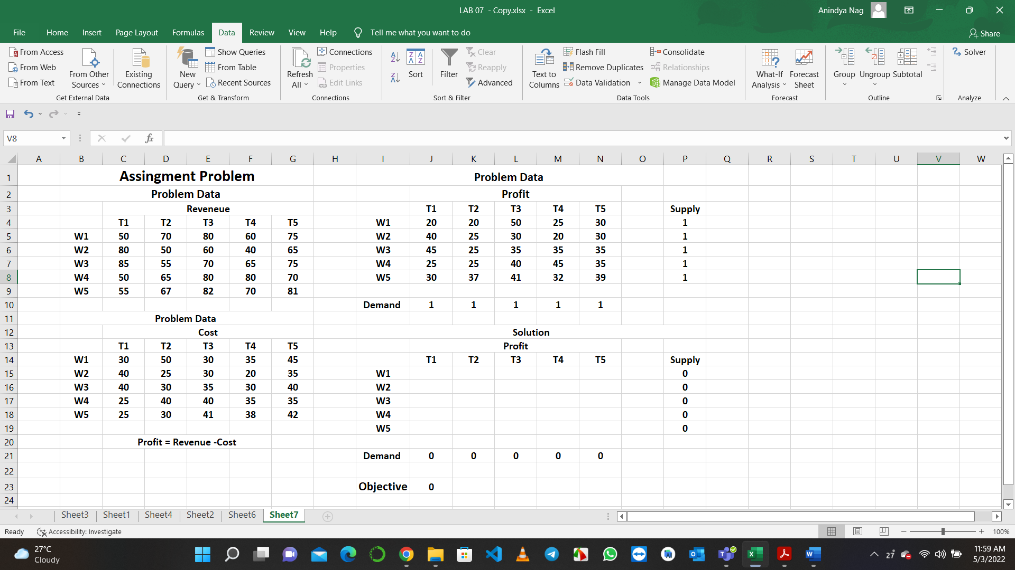

**In Microsoft Excel, after entering the entire Assignment Problem data in the worksheet, the following steps would lead to a solution:**

**Step 1:**

* Select **Data** menu in the toolbar.

**Step 2:**

* In Data menu, select **Solver** application.

**Step 3:**

* Open Solver application. In Solver parameters dialog box Enter **$J$23** in set target cell. Select purpose of **max** (depending on the type of the objective). Enter **$J$15:$N$19** in by changing cell box. To enter constraint equations, click on **Add** button.

**Step 4:**

* When the **Add** constraint dialog box opens, it would have three boxes: first, cell reference; second, inequalities of **≤** and lastly, constraint box. For supply constraints, enter **$P$15:$P$19** in cell reference box; enter inequality of **=**  and **$P$4:$P$8** in the constraint box. Then click on Add to add demand constraints in the similar process. After entering all constraints, click **OK**.

**Step 5:**

* Now choose Options. Select Assume Non-Negative and Assume Linear Model (in **MS Excel 2007**). In **Excel 2010** onwards, select Make Unconstraint Variables Non-negative and select Simplex LP from the dropdown menu of Select a Solving Method. Click **OK**.

**Step 6:**

* When Solver parameters dialog box appear, click on **Solve**.

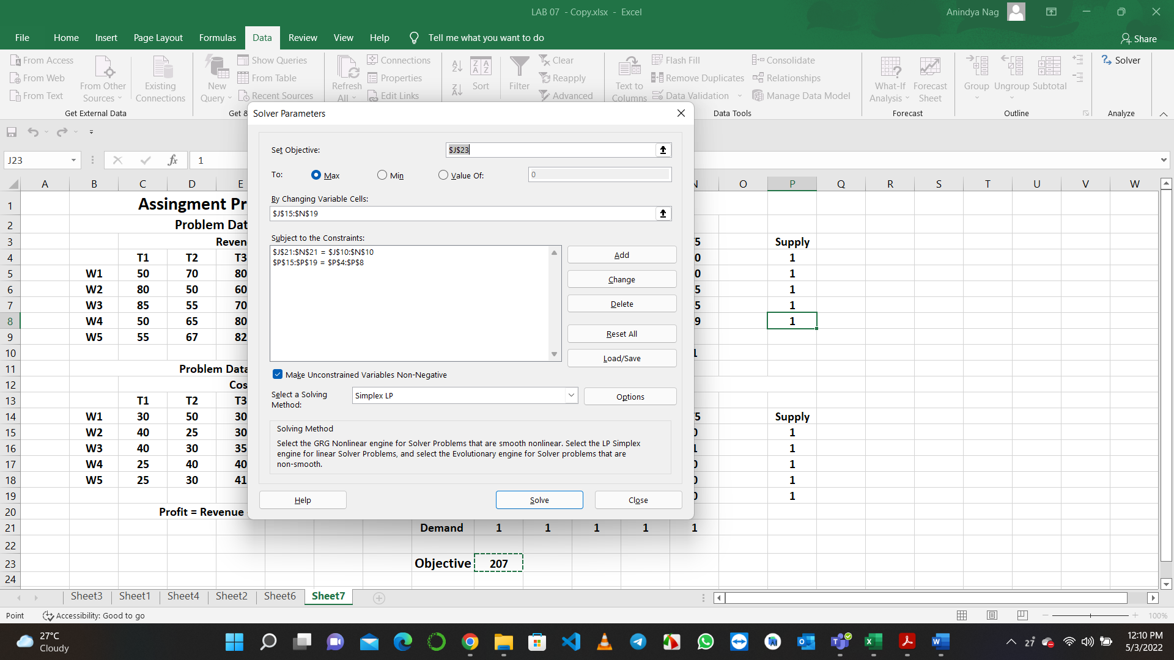

**Step 7.:**

* Finally, when final solution appears on the worksheet, select Keep Solver Solution and click **OK**.

**Output:**

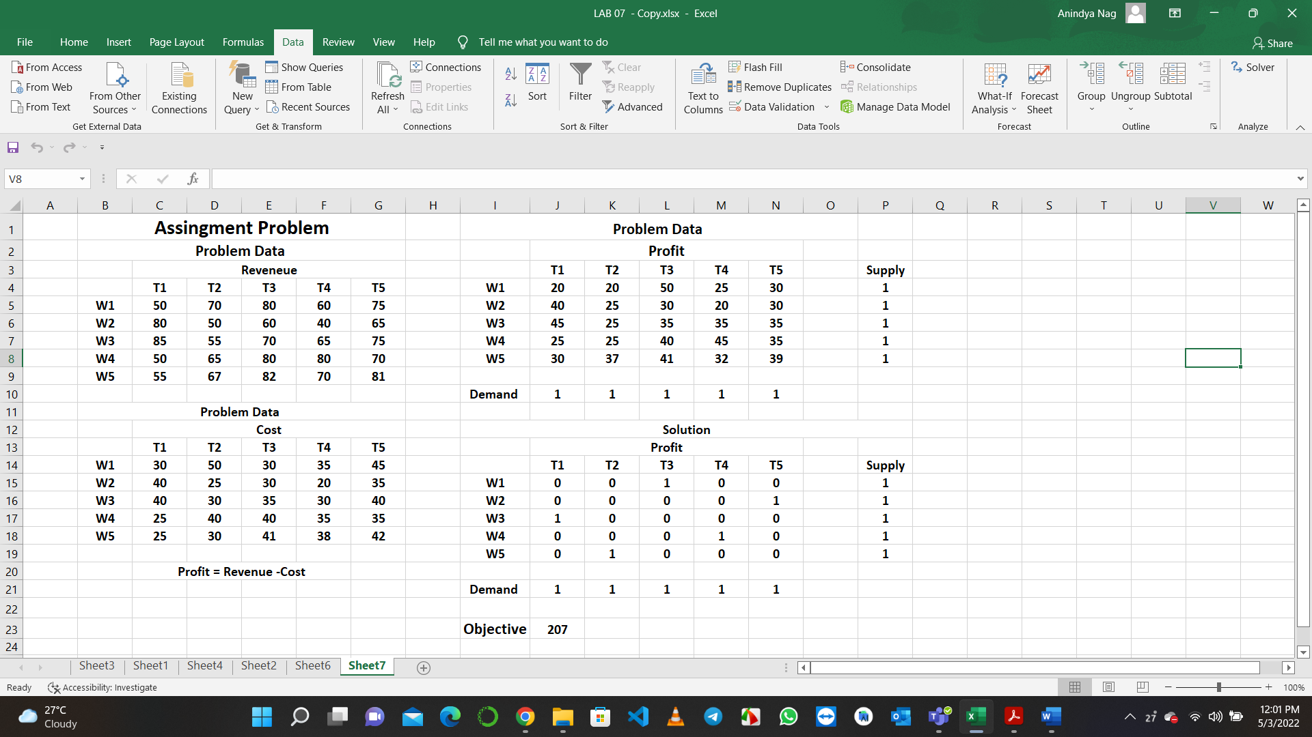

**Conclusion:**

**The obtained optimal assignment of the assignment problem with the maximum profit is given by:**

$$W_{1} → { T}_{3}$$

$$W_{2} → T_{5}$$

$$W_{3 }→ T_{1}$$

$$W_{4} → { T}_{4}$$

$$W_{5} → T_{2}$$

**Maximum Profit $=50+30+45+45+37=207$**